Geo-Social Mangrove Extent Baseline Report – August 2025
Prepared under the WACA Blue Carbon Assessment, Ghana

Client:
Ministry of Environment, Science, and Technology (MEST)
Ministry of Lands and Natural Resources (MLNR)

Prepared by:
Ecological Nest Ltd.
P.O. Box DT 567, Adenta, Accra, Ghana
Email: info@ecologicalnest.org | Tel: +233 262 714 148
Website: www.ecologicalnest.org

Date:
August 2025

Confidential – Prepared for MEST & MLNR under the WACA Blue Carbon Assessment Project

List of Acronyms
CCA – Community Change Agent
CREMA – Community Resource Management Area
EPA – Environmental Protection Agency
ESMF – Environmental and Social Management Framework
FPIC – Free, Prior, and Informed Consent
GEE – Google Earth Engine
GIS – Geographic Information Systems
IPCC – Intergovernmental Panel on Climate Change
MLNR – Ministry of Lands and Natural Resources
MEST – Ministry of Environment, Science, and Technology
MRV – Monitoring, Reporting, and Verification
NDPC – National Development Planning Commission
NDVI – Normalized Difference Vegetation Index
NDC – Nationally Determined Contribution
NGO – Non-Governmental Organization
RF – Random Forest
SDGs – Sustainable Development Goals
UCC – University of Cape Coast
IESS – Institute for Environment and Sanitation Studies (University of Ghana)
VSLAs – Village Savings and Loan Associations
WACA – West Africa Coastal Areas Resilience Investment Project
WD – Wildlife Division

Contents
Executive Summary 2
Section 1: A New Ecological Baseline: High-Resolution Mapping of Ghana's Coastal Mangrove Ecosystems 3
1.1. Overview of the 2024 Geospatial Assessment 3
1.2. The Primacy of the Keta Lagoon Complex 4
1.3. Songor and Muni-Pomadze: Landscapes of Degradation and Limited Extent 4
1.4. National Distribution and Fragmentation Patterns 5
Section 2: Reconciling Past and Present: A Methodological Analysis of Mangrove Extent Discrepancies 5
2.1. Historical Estimates of Ghana's Mangrove Cover 6
2.2. The Technological Leap: Advanced Remote Sensing Techniques 7
2.3. The Importance of Ground-Truthing and Participatory Mapping 8
2.4. Conclusion: A More Accurate Picture, Not a Sudden Increase 9
Section 3: The Human-Mangrove Nexus: Spatially Validating Livelihood Dependency and Resource Pressure 10
3.1. Mapping the Socio-Economic Landscape 10
3.2. Geospatial Validation of High Livelihood Dependency 10
3.3. Case Study: The Keta Lagoon Fuelwood-Fisheries Nexus 11
3.4. Contextualizing the Volta Delta Dynamics 12
Section 4: Mapping Degradation Drivers and Prioritizing Restoration Opportunities 13
4.1. Geospatial Evidence of Degradation Drivers 13
4.2. An Evidence-Based Framework for Prioritizing "Early Action Hubs" 15
4.3. Identifying New Restoration and Conservation Zones 17
Section 5: A Geo-Social Framework for Verifiable Blue Carbon Interventions 18
5.1. Foundational Requirements for Carbon Standard Compliance 18
5.2. Proposed Zonation for CREMA and Restoration Planning 18
5.3. Targeted Co-Benefit Interventions 19
5.4. Mapping and Mitigating Social Risks 20
Section 6: Strategic Recommendations for a Robust and Equitable Blue Carbon Program 21
6.1. For MLNR/MEST (National Level) 21
6.2. For the Wildlife Division and Forestry Commission (Operational Level) 21
6.3. For District Assemblies (Local Government Level) 22
6.4. For the Blue Carbon Project Design Team 22

An Integrated Geo-Social Baseline for Blue Carbon Initiatives on the Coast of Ghana: Validating Socio-Economic Realities and Re-evaluating Mangrove Extent for Carbon Standard Compliance

Executive Summary
This report establishes a new, authoritative geo-social baseline for Ghana's coastal zone, integrating high-resolution remote sensing data with extensive socio-economic field research to inform the design of a blue carbon initiative compliant with international carbon standards. The analysis reveals a total coastal mangrove extent of 2.81% of the landscape (approximately 30,025 hectares), a figure significantly larger than most historical estimates. This discrepancy is not indicative of recent ecosystem expansion but is attributed to advanced remote sensing methodologies, including the use of 20-meter resolution Sentinel-2 imagery and a robust Random Forest classification algorithm, which have captured smaller, fragmented, and fringing mangrove stands previously unmapped.¹
A primary finding of this assessment is the overwhelming national significance of the Keta Lagoon Complex Ramsar Site. This single ecosystem contains an estimated 20,717.95 hectares of mangroves, constituting approximately 69% of Ghana's total coastal mangrove resource.¹ This concentration establishes the Keta Lagoon as the nation's principal blue carbon asset, making its effective management a matter of strategic national importance for meeting climate and biodiversity targets.
The report spatially validates key findings from the socio-economic baseline study conducted across 37 communities.¹ The high dependency on mangrove-linked livelihoods, with over 70% of households in the study areas reliant on activities such as fish smoking and fuelwood harvesting, is geographically correlated with the dense, extensive mangrove stands of the Keta Lagoon.¹ Conversely, the minimal mangrove cover mapped in the Songor Ramsar Site (465.76 hectares) provides stark, quantitative evidence of severe degradation linked directly to the expansion of salt production, a claim consistently raised in community consultations.¹ The mangrove extent in the Muni-Pomadze Ramsar Site was found to be ecologically insignificant, highlighting a landscape of advanced degradation requiring intensive restoration efforts.¹
This integrated analysis provides a robust, evidence-based framework for designing a carbon project compliant with Verra, Gold Standard, or Plan Vivo standards. It substantiates the strategic selection of "early action hubs" Sankor, Pute, and Dzita by aligning their documented social readiness and community cohesion with specific ecological conditions and restoration potential.¹ Furthermore, the baseline provides a spatially explicit foundation for targeting co-benefit interventions, mapping and mitigating social risks such as land tenure disputes and elite capture, and establishing a scientifically sound and participatory Monitoring, Reporting, and Verification (MRV) system.
Given the concentration of Ghana's blue carbon potential and the intense, localized pressures within a fragmented governance landscape, a focused, high-priority conservation and co-management strategy is urgently required for the Keta Lagoon Complex. Safeguarding this critical national asset is paramount to the success of any national blue carbon program and to securing long-term climate finance.

Section 1: A New Ecological Baseline: High-Resolution Mapping of Ghana's Coastal Mangrove Ecosystems

1.1. Overview of the 2024 Geospatial Assessment
The 2024 geospatial assessment of Ghana's coastal zone represents a significant advancement in the nation's understanding of its blue carbon ecosystems, establishing a new and more accurate benchmark for mangrove resources. The study, which covered a total coastal landscape of 1,068,361.48 hectares spanning 35 political districts, determined that mangrove ecosystems cover 2.81% of this area, equivalent to approximately 30,025 hectares.¹ This finding provides an updated and more robust foundation for national carbon accounting, conservation planning, and aligning with Nationally Determined Contributions (NDCs) under the Paris Agreement. The methodology, detailed further in Section 2, leverages modern satellite technology and machine learning to provide a granular view of the ecosystem's extent and distribution, forming the definitive ecological baseline for the WACA Blue Carbon initiative.

1.2. The Primacy of the Keta Lagoon Complex
The most significant finding of the geospatial assessment is the paramount importance of the Keta Lagoon Complex Ramsar Site. Analysis of the landcover data reveals that this single site in the Volta Region contains an estimated 20,717.95 hectares of mangroves.¹ This constitutes an astonishing 69% of the entire coastal mangrove resource identified in the study. This concentration positions the Keta Lagoon not merely as a site of local importance, but as the central pillar of Ghana's national blue carbon strategy.
The spatial distribution within the site is characterized by large, continuous stretches of mangrove, particularly in the areas between the main lagoon body and the Volta River estuary.¹ This geographic arrangement, visualized in the site's mangrove distribution map, underscores the hydrological connectivity and ecological integrity of the system, which supports vast areas of both Red Mangrove (Rhizophora racemosa) and Black Mangrove (Avicennia germinans).¹ The sheer scale of this resource explains the deep-seated socio-economic reliance of the surrounding communities, a dynamic explored in Section 3. The data confirms that any effort to secure national-level blue carbon benefits must prioritize the conservation and sustainable management of this singular, critical asset.

1.3. Songor and Muni-Pomadze: Landscapes of Degradation and Limited Extent
In stark contrast to the Keta Lagoon, the geospatial assessment of the Songor and Muni-Pomadze Ramsar sites paints a picture of severe historical and ongoing ecosystem degradation. The Songor Ramsar Site, despite its international importance and significant economic activity, was found to contain only 465.76 hectares of mangroves, representing a mere 2% of the national coastal total.¹ This limited extent, visible in the landcover map as small, fragmented patches, provides quantitative evidence supporting the socio-economic findings that link widespread mangrove loss to the expansion of salt mining and other anthropogenic pressures.¹
The situation in the Muni-Pomadze Ramsar Site is even more critical. The assessment concluded that the extent of mangrove cover was "insignificant".¹ While small, degraded fringes may persist, they do not form a mappable, functional ecosystem at the scale of the analysis. This finding does not diminish the site's ecological or cultural importance, particularly its tidal marshes and sacred groves, but it reframes its role within the blue carbon initiative. Rather than a landscape for conservation of existing carbon stocks, Muni-Pomadze represents a priority landscape for restoration and rehabilitation, where interventions would aim to re-establish a lost ecosystem. These findings highlight the varied ecological starting points across the three project sites, necessitating tailored strategies for intervention.

1.4. National Distribution and Fragmentation Patterns
Beyond the three focal Ramsar sites, the assessment provides a comprehensive overview of the national distribution of mangroves along Ghana's 550 km coastline. The mangrove distribution map reveals that outside of the Keta stronghold, the resource is highly fragmented, occurring in patches primarily located within wetlands, estuaries, and lagoons.¹ Notable concentrations, though significantly smaller than Keta, were identified in areas around Ada (Songor), Winneba (Muni-Pomadze), Shama, and the Amansuri Wetland in the Western Region.¹
This pattern of a single large, contiguous ecosystem and numerous smaller, isolated fragments has profound implications for management. The fragmentation increases the vulnerability of these smaller patches to localized threats and reduces their overall ecological resilience and connectivity. This national context reinforces the strategic logic of a dual approach for the blue carbon initiative: first, securing the large, intact carbon stocks of the Keta Lagoon Complex, and second, implementing targeted restoration and connectivity-building activities to stabilize and expand the smaller, fragmented mangrove patches across the rest of the coastal landscape. The success of Ghana's national blue carbon program is therefore disproportionately dependent on the fate of the Keta ecosystem. Any significant threat to its mangroves is not just a local environmental issue but a strategic risk to the country's ability to meet its climate targets and leverage international carbon finance.

Section 2: Reconciling Past and Present: A Methodological Analysis of Mangrove Extent Discrepancies

2.1. Historical Estimates of Ghana's Mangrove Cover
To establish the significance of the 2024 geospatial assessment, it is essential to contextualize its findings against the backdrop of previous estimates of Ghana's mangrove extent. Historical data, derived from a variety of methodologies and time periods, have presented a wide and often inconsistent range of figures, creating uncertainty for national-level planning. As shown in Table 1, estimates over the past two decades have varied from as low as 7,240 hectares (72.4 km²) in a 2013 assessment to as high as 18,100 hectares (181 km²) in a 1980 baseline.³ This variability underscores the challenges in accurately mapping this complex coastal ecosystem and highlights the critical need for a new, methodologically superior baseline that can be confidently used for carbon accounting and project design.
Table 1: Comparative Analysis of Ghana's National Mangrove Extent Estimates
Study/Source | Year of Data | Estimated Extent (ha) | Methodology | Geographic Scope
WACA GIS Report (2024) ¹ | 2024 | 30,025 | Sentinel-2 (20m), GEE, Random Forest Classification, Participatory Ground-Truthing | National Coastal
Nunoo & Agyekumhene (2022) ³ | 2013 | 7,240 | Landsat 8 (30m), Supervised Classification, Field Visits | National Coastal
Ashiagbor et al. (2021) ⁵ | 2020 | 4,102 | Sentinel-1 (Radar), Support Vector Machine, Field Data | Keta Lagoon Only
WACA Program (2021) ⁶ | 1980 | 18,100 | Literature Review/Previous Studies | National Coastal
Ajonina et al. (2014) in ⁷ | 2014 | 13,700 | Not Specified | National Coastal
UNEP (2007) in ⁴ | 2006 | 13,700 | Not Specified | National Coastal
The BFT Online (2025) ⁸ | 2000 / 2022 | 14,000 / <11,000 | News Report/Expert Opinion | National Coastal
ITTO (2011) ⁹ | 2011 | 11,200 | Satellite Imagery Analysis | National Coastal

2.2. The Technological Leap: Advanced Remote Sensing Techniques
The primary reason for the substantially larger mangrove area identified in the 2024 assessment lies in a significant technological and methodological leap forward from previous efforts. This new baseline is not the result of a sudden ecological expansion but of a more accurate and sensitive measurement capability.
First, the study utilized Harmonised Sentinel-2 multispectral satellite imagery, which provides data at a 10 to 20-meter spatial resolution.¹ This is a marked improvement over many past national and global assessments that relied on the 30-meter resolution of Landsat imagery.¹⁰ In a heterogeneous landscape like Ghana's coast, where mangroves often exist as narrow fringes along lagoons or in small, fragmented patches, the higher resolution of Sentinel-2 is critical. It allows for the detection and accurate classification of smaller stands that would have been missed or misclassified as mixed pixels in the coarser Landsat data, a known limitation of previous large-scale mapping efforts.¹⁰
Second, the analytical engine employed was far more powerful than what was previously accessible. The entire analysis was conducted on the Google Earth Engine (GEE), a cloud-based platform that enables the processing of vast archives of satellite data without the constraints of local computing power.¹ This allowed the team to create a cloud-free composite image for the entire year of 2024, mitigating the persistent cloud cover that often plagues optical remote sensing in West Africa.¹⁰ The classification itself was performed using a Random Forest (RF) classifier, a robust machine learning algorithm renowned for its high accuracy in handling complex land cover classifications with numerous input variables.¹ To further enhance accuracy, a wide array of spectral indices (such as NDVI, EVI, and NDWI) were generated and included in the classification model. These indices accentuate specific characteristics of vegetation and water, enabling the algorithm to more reliably distinguish mangrove canopies from spectrally similar classes like other wetland forests or grasslands.¹

2.3. The Importance of Ground-Truthing and Participatory Mapping
The technological sophistication of the remote sensing analysis was critically complemented by a robust process of ground-truthing and community engagement. This synergy between top-down satellite analysis and bottom-up local knowledge is a cornerstone of the new baseline's credibility and is a key requirement for certification under standards like Plan Vivo, which emphasize stakeholder participation.
The GIS report explicitly states that the classification model was trained and validated using a total of 319 reference data points.¹ These points were not generated from remote interpretation alone; they were collected through a participatory process involving field visits with local community members and technical officers, supplemented by interpretation of very high-resolution Google Earth imagery for inaccessible areas.¹ This ensures that the algorithm's understanding of what constitutes "mangrove" on the ground is accurate and context-specific.
This process is corroborated by the socio-economic baseline report, which details the use of Participatory Resource Mapping as a key data collection tool.¹ During these sessions, community members, who possess generations of intimate knowledge of their local environment, drew maps of their resource areas. A notable outcome of this exercise was the identification of "previously undocumented mangrove stands compared to the global data".¹ This local knowledge was invaluable for guiding the field teams, refining the training data for the satellite image classification, and ensuring that the final map reflects the true, lived-in landscape. This integration validates the remote sensing results and builds local ownership of the final map, a crucial element for the long-term success of any community-based management initiative.

2.4. Conclusion: A More Accurate Picture, Not a Sudden Increase
In conclusion, the new estimate of 30,025 hectares of mangrove cover should not be interpreted as evidence of a massive, recent expansion of mangrove forests in Ghana. Rather, it represents a more accurate, detailed, and inclusive measurement of the existing ecosystem. The combination of higher-resolution satellite data, advanced cloud computing and machine learning, and participatory ground-truthing has allowed for the inclusion of previously unmapped fragments and fringes.
This methodological improvement does more than just update a national statistic; it fundamentally changes the understanding of the character of Ghana's mangrove ecosystems. Where coarser maps may have depicted a few isolated, remnant forests, the new high-resolution map reveals a more complex reality: a mosaic of core forest areas connected by smaller fragments, regenerating patches, and potential corridors. This suggests a landscape with greater potential for natural regeneration and ecological connectivity than previously assumed. Consequently, this revised understanding should inform a more nuanced restoration strategy, one that not only focuses on large-scale planting in completely deforested areas but also prioritizes the protection of these smaller fragments and the enhancement of connectivity between them through assisted natural regeneration, an often more cost-effective and ecologically resilient approach. This new baseline, therefore, provides the most scientifically robust and defensible foundation for all future blue carbon project development, monitoring, and reporting in Ghana.

Section 3: The Human-Mangrove Nexus: Spatially Validating Livelihood Dependency and Resource Pressure

3.1. Mapping the Socio-Economic Landscape
The true value of the new ecological baseline is realized when it is integrated with the rich, qualitative data from the socio-economic assessment. The first step in this integration is to overlay the spatial locations of the 37 communities profiled in the socio-economic report onto the new mangrove distribution maps.¹ This simple act transforms the static ecological map into a dynamic geo-social planning tool, allowing for a spatial analysis of the complex relationships between human populations and the mangrove resources upon which they depend. By visualizing where people live in relation to the resource, it becomes possible to test, validate, and quantify the claims made during community consultations and to identify geographic hotspots of dependency, pressure, and vulnerability.

3.2. Geospatial Validation of High Livelihood Dependency
A central finding of the socio-economic baseline report is the profound reliance of coastal communities on mangrove ecosystems. The report asserts that "Over 70% of households depend on mangrove-linked activities," specifically citing fish smoking, salt production, and fuelwood harvesting as primary sources of income and subsistence.¹ The integrated geo-social analysis provides powerful spatial validation for this claim.
There is a clear and strong geographical correlation between the communities reporting the highest levels of dependency and their immediate proximity to the densest and most extensive mangrove stands in the country. This is most evident in the Keta Lagoon Complex. Communities such as Dzita, Sota, Agbatsivi, Bomigo, and Galo, all of which were identified as having deep-seated reliance on the lagoon's resources, are situated directly adjacent to or within the vast 20,717.95-hectare mangrove forest depicted in the GIS map.¹ The sheer scale of the available resource in Keta has fostered a deeply embedded socio-economic system built around its exploitation. In contrast, communities in the Muni-Pomadze area, where mangrove cover is insignificant, have more diversified livelihoods centered on farming and charcoal production from upland forests, with a much lower direct dependency on mangroves.¹ This spatial correlation demonstrates that the "70% dependency" figure is not a uniform national average but a localized reality driven by resource availability, particularly concentrated in the Keta region.

3.3. Case Study: The Keta Lagoon Fuelwood-Fisheries Nexus
A deeper analysis of the Keta Lagoon Complex reveals a tightly coupled social-ecological system where livelihood dependency and resource degradation are locked in a reinforcing feedback loop. The vast mangrove resource has historically supported a thriving artisanal fishing industry, which is the dominant occupation for men in the region.¹ This, in turn, has created a large and economically vital post-harvest sector, dominated by women, centered on the smoking and processing of fish for local and regional markets.¹
The critical link in this chain is energy. The primary fuel source for the thousands of fish smoking kilns operating in communities like Agbatsivi, Galotse, Bomigo, and Salo is mangrove wood, which is preferred for its burning characteristics.¹ This creates an intense and relentless demand for fuelwood, leading to the unsustainable harvesting and degradation of the very mangrove ecosystem that serves as a critical nursery habitat for the fish stocks the entire local economy is built upon. The GIS maps, when overlaid with community locations, visually demonstrate this pressure: the most accessible mangrove stands closest to major settlements often show signs of degradation or fragmentation.
This analysis reveals a classic "social-ecological trap." The immense natural capital of Keta's mangroves has fostered an intense economic dependency, and the practices required to sustain that economy are now the primary drivers of the ecosystem's degradation. Any successful blue carbon intervention in this region must therefore go beyond simple tree planting. It must fundamentally address this feedback loop by introducing viable alternatives, such as improved, fuel-efficient cookstoves and diversified livelihood options, to reduce the pressure at its source.

3.4. Contextualizing the Volta Delta Dynamics
The social-ecological trap of the Keta Lagoon is further complicated by a larger, landscape-level driver that poses a long-term existential threat to the entire system: the altered hydrology of the Volta River Delta. The construction of the Akosombo Dam in 1964, located 60 km upstream, has had a profound and lasting impact on the delta's geomorphology. The dam traps over 90% of the river's natural sediment load, effectively starving the delta of the sand and silt required to build and maintain its coastline against the erosive power of the Atlantic Ocean.¹⁸
This reduction in sediment supply has triggered a regime shift, transforming the delta from a river-dominated, pro-grading system to a wave-dominated, eroding system.²⁰ This has resulted in significant and ongoing coastal erosion along the narrow sandspit that separates the Keta Lagoon from the sea, a phenomenon directly observed and reported by communities during the socio-economic fieldwork.¹ This overarching landscape instability places the entire 20,717.95-hectare mangrove ecosystem at risk. The long-term survival of these forests is dependent on the stability of the landform upon which they grow. Therefore, the baseline for any carbon project in this area must account for this significant, non-project-related risk. Project activities, while crucial, are operating within a dynamic and vulnerable landscape shaped by powerful forces far beyond the project's immediate control. This necessitates a strong focus on adaptation and resilience-building measures alongside mitigation activities.

Section 4: Mapping Degradation Drivers and Prioritizing Restoration Opportunities

4.1. Geospatial Evidence of Degradation Drivers
The integrated geo-social baseline provides a powerful tool for visually and quantitatively validating the drivers of mangrove degradation identified by communities in the socio-economic report. By overlaying land use data with community locations and socio-economic information, a clear picture of cause and effect emerges at the landscape scale.
A compelling example is the case of the Songor Ramsar Site. The socio-economic report highlights the claim that "Mangrove degradation is highest near salt production zones (e.g., Elavanyo, Obane)".¹ The new GIS landcover map for Songor serves as definitive proof of this assertion. The map shows a landscape dominated by salt pans and grasslands, with only 465.76 hectares of mangroves remaining in small, isolated patches.¹ This spatial evidence demonstrates the outcome of a long-term land-use conflict where the expansion of industrial and artisanal salt mining has led to the systematic clearing of mangrove forests.¹ The map does not just show degradation; it shows the near-complete replacement of one ecosystem type by another for economic purposes.
Similarly, the GIS data can be used to analyze the impacts of population pressure and pollution. By examining mangrove density and health (inferred from spectral indices like NDVI) in relation to proximity to high-population centers and waste hotspots identified in the socio-economic report, such as Dzogborve in Keta, it is possible to identify areas where human activity is causing the most acute stress.¹ This spatial analysis moves the identification of degradation drivers from anecdotal community reports to a verifiable, evidence-based assessment, which is essential for credible project design and monitoring.
Table 2: Spatial Correlation Matrix of Degradation Drivers and GIS Evidence
Degradation Driver ¹ | Key Communities Affected ¹ | GIS Evidence/Indicator ¹ | Level of Confidence
Fuelwood Harvesting | Agbatsivi, Galotse, Bomigo, Salo (Keta) | Low mangrove density and high fragmentation near settlements; proximity to fishing communities. | High
Salt Pan Expansion | Elavanyo, Obane, Pute (Songor) | Near-total absence of mangrove cover within and adjacent to large, mapped salt production areas. | High
Agricultural Expansion | Bewadze (Muni), Dzita (Keta) | Mangrove/wetland boundary directly abutting mapped cropland areas. | Medium
Plastic & Solid Waste Pollution | Dzogborve, Galotse (Keta) | Proximity of waste hotspots to sensitive estuarine and mangrove zones. | High
Coastal Erosion | Dzita, Akplorwotorkor (Keta) | Mangrove stands located on narrow, vulnerable sandspits susceptible to shoreline change. | High

4.2. An Evidence-Based Framework for Prioritizing "Early Action Hubs"
The socio-economic report identified three communities, Sankor (Muni-Pomadze), Pute (Songor), and Dzita (Keta) as potential "early action hubs" for piloting blue carbon activities, based on social criteria such as community cohesion, engaged leadership, and momentum for establishing Community Resource Management Areas (CREMAs).¹ However, the verification report correctly noted that this selection lacked a clear, documented rationale and required stronger justification.¹ The integrated geo-social baseline now provides the necessary evidence to construct that justification, creating a transparent and defensible framework for prioritization.
By combining the documented social strengths of each community with an objective assessment of their ecological context from the GIS data, a clear strategic rationale for each selection emerges:
- Dzita (Keta Lagoon Complex): This community exhibits strong social readiness, with active local groups and a history of engagement with NGOs.¹ This social capital is paired with a critical ecological location, situated on the coastal barrier spit adjacent to significant, albeit heavily pressured, mangrove resources.¹ This combination makes Dzita an ideal pilot site for testing community-led conservation models, sustainable harvesting practices, and restoration activities within a high-value, high-pressure ecosystem.
- Sankor (Muni-Pomadze): The socio-economic report highlights Sankor's high community cohesion, active women's groups, and ongoing, locally-led mangrove nursery and restoration efforts.¹ While the GIS assessment shows "insignificant" mangrove cover for the Muni-Pomadze site as a whole, this context makes Sankor's proactive efforts even more critical.¹ It is a prime location for piloting intensive restoration and ecosystem re-establishment techniques in a severely degraded landscape, building on existing community momentum.
- Pute (Songor): Pute is characterized by proactive traditional leadership and a strong interest in CREMA formation.¹ This social strength is situated within the highly contentious and degraded landscape of the Songor Ramsar Site, marked by land disputes and the dominance of salt mining.¹ This makes Pute a strategic, albeit challenging, site for piloting interventions focused on conflict resolution, land-use planning, and restoration in a complex, multi-stakeholder environment where securing tenure and community rights is a prerequisite for ecological success.
Table 3: Integrated Profile of Prioritized Early Action Hubs
Hub Community | Ramsar Site | Socio-Economic Strengths ¹ | Ecological Condition ¹ | Strategic Rationale for Selection
Dzita | Keta Lagoon Complex | Active local groups, NGO presence, high CREMA readiness, eco-tourism potential. | Adjacent to large but degraded mangrove stands; high erosion risk. | Pilot community-led conservation and restoration in a high-value, high-pressure carbon stock area.
Sankor | Muni-Pomadze | Strong community cohesion, active women’s group, existing mangrove nursery. | Insignificant existing mangrove cover; highly degraded landscape. | Pilot intensive restoration and ecosystem re-establishment, building on existing community initiative.
Pute | Songor | Proactive traditional leadership, high interest in CREMA formation. | Minimal, fragmented mangrove cover; high land-use conflict (salt). | Pilot conflict resolution, land-use planning, and restoration in a complex, high-risk environment.

4.3. Identifying New Restoration and Conservation Zones
Beyond validating the pre-identified hubs, the integrated baseline serves as a powerful tool for identifying new areas of opportunity for conservation and restoration across the entire coastal landscape. By analyzing the landcover classification, it is possible to pinpoint areas that are prime candidates for specific types of intervention.
For example, areas classified as "open forest" or "grassland" that are directly adjacent to existing mangrove stands can be designated as priority zones for restoration. These areas likely supported mangroves historically and may have favorable soil and hydrological conditions for successful replanting or, in some cases, for assisted natural regeneration, which can be more cost-effective.
Conversely, the GIS data clearly identifies the remaining intact, high-density mangrove areas, particularly within the Keta Lagoon Complex. These areas should be designated as core conservation zones within CREMA management plans. The immediate priority for these zones is not restoration but protection from encroachment and unsustainable harvesting. By layering the community classification system from the socio-economic report (which categorizes communities as coastal, inland, degraded, or vulnerable) onto this ecological opportunity map, the project can further refine its targeting, ensuring that interventions are not only ecologically sound but also socially equitable and responsive to local vulnerabilities.¹

Section 5: A Geo-Social Framework for Verifiable Blue Carbon Interventions

5.1. Foundational Requirements for Carbon Standard Compliance
The development of a credible and certifiable blue carbon project requires a baseline that is not only scientifically robust but also meets the specific principles and criteria set forth by leading international carbon standards such as the Verified Carbon Standard (Verra) and the Plan Vivo Standard. The integrated geo-social baseline presented in this report has been explicitly designed to meet these requirements.
First, it establishes a clear and quantifiable baseline scenario for both carbon stocks (through the high-resolution mangrove extent map) and socio-economic conditions (through the detailed community profiling).¹ This allows for the demonstration of additionality, proving that project interventions will lead to carbon sequestration and social benefits beyond what would have occurred in a business-as-usual scenario.
Second, the methodology's deep integration of stakeholder engagement, from participatory resource mapping to the validation of socio-economic data, directly addresses the standards' requirements for Free, Prior, and Informed Consent (FPIC) and genuine community participation.¹ Finally, the baseline provides the necessary data to design a comprehensive plan for monitoring not only carbon but also the co-benefits, such as livelihood improvements and gender empowerment which is a core component of high-quality carbon projects, particularly under the Verra Climate, Community & Biodiversity (CCB) Standards and Plan Vivo.

5.2. Proposed Zonation for CREMA and Restoration Planning
The integrated baseline enables a transition from broad-stroke national policies to granular, site-specific spatial planning. A key application of this is the development of zonation maps within the framework of Community Resource Management Areas (CREMAs). By leveraging the combined ecological and social data, communities and managing authorities can co-design management plans that balance conservation with sustainable use. A proposed zonation model would include:
- Core Conservation Zones: These would encompass the intact, high-density, and spiritually significant mangrove areas identified in the GIS report and through participatory mapping.¹ Activities within these zones would be highly restricted, focusing on protection and non-extractive uses like scientific monitoring or limited eco-tourism. The primary goal is to secure the largest existing carbon stocks.
- Sustainable Use Zones: These zones would be designated in areas of healthy but accessible mangroves where communities have traditionally harvested resources. Here, the CREMA by-laws would establish clear, scientifically-informed rules for regulated harvesting (e.g., quotas, designated cutting seasons, size limits) to ensure that local livelihood needs are met without compromising the overall health of the ecosystem.
- Restoration Priority Zones: This designation would apply to areas identified as degraded in the GIS assessment, including former mangrove areas now classified as "grassland" or "open forest".¹ These zones would be the focus of active project interventions, such as community-led mangrove planting and assisted natural regeneration, with the explicit goal of enhancing carbon sequestration and restoring ecosystem services.

5.3. Targeted Co-Benefit Interventions
A key strength of the geo-social baseline is its ability to guide the efficient and impactful targeting of co-benefit interventions. Rather than applying a one-size-fits-all approach, the project can direct resources to where they are most needed and most likely to succeed.
- Improved Cookstoves: The socio-economic report confirms near-universal dependence on fuelwood for fish smoking and cooking, a primary driver of mangrove degradation.¹ The baseline allows for the precise identification of the highest priority communities for the introduction of fuel-efficient cookstoves. These would be communities that exhibit a combination of factors: high documented fuelwood dependency, immediate proximity to degraded mangrove areas shown on the GIS map, and the presence of organized women's groups who dominate the fish smoking industry and can act as effective champions and distribution hubs for the new technology.¹
- Plastic Waste Management: The socio-economic report identified several "plastic waste hotspots," such as Dzogborve and Klonu in the Keta Lagoon Complex, where pollution poses a significant threat to wetland health.¹ The baseline map can pinpoint these locations and recommend them as pilot sites for circular economy initiatives, as discussed in the socio-economic report.¹ These interventions, such as supporting youth-led plastic collection and recycling enterprises, can generate social co-benefits (employment) and environmental co-benefits (reduced pollution), and potentially open pathways to emerging plastic credit markets.

5.4. Mapping and Mitigating Social Risks
A responsible carbon project must proactively identify and mitigate potential social risks. The integrated baseline provides the data necessary to create a social risk map, which is a critical tool for the project's Environmental and Social Management Framework (ESMF).
The socio-economic report and verification log identify significant risks in specific zones, including unresolved land tenure issues and the potential for elite capture of project benefits.¹ By plotting the locations of communities where these risks are most acute onto the landcover and proposed intervention maps, the project can anticipate and plan for potential conflicts. This spatial analysis is crucial for designing a targeted and robust safeguard strategy.
For instance, the FPIC process must be intensified in these mapped high-risk zones, with additional consultations and more rigorous documentation to ensure consent is genuinely free, prior, and informed. Furthermore, the baseline highlights a critical institutional gap: grievance systems are "informal or non-existent in over 80% of communities".¹ This finding necessitates the establishment of formal, accessible, and transparent Grievance Redress Mechanisms (GRMs) as a foundational activity, particularly in the identified high-risk areas. Finally, the design of benefit-sharing mechanisms must be carefully structured in these zones to be resilient to elite capture, potentially by channeling benefits through broad-based community structures like women's VSLAs rather than through potentially compromised traditional leadership.

Section 6: Strategic Recommendations for a Robust and Equitable Blue Carbon Program

6.1. For MLNR/MEST (National Level)
- Recommendation 1: Adopt the New National Baseline: It is recommended that the Ministry of Lands and Natural Resources (MLNR) and the Ministry of Environment, Science and Technology (MEST) formally adopt the 2024 geospatial assessment as the new official national baseline for mangrove extent. This updated figure of approximately 30,025 hectares should be used to revise Ghana's Nationally Determined Contribution (NDC), National Biodiversity Strategy and Action Plan (NBSAP), and other national climate and environmental strategies to accurately reflect the country's significantly larger blue carbon asset and potential.¹
- Recommendation 2: Designate Keta Lagoon as a National Strategic Stock: Given that the Keta Lagoon Complex holds an estimated 69% of the nation's entire coastal mangrove resource, it should be designated as a "National Blue Carbon Strategic Stock".¹ This designation should trigger the development of a dedicated, multi-stakeholder management and investment plan that addresses the unique and dual pressures identified in this report: intense local livelihood dependency and overarching landscape instability driven by the altered dynamics of the Volta River Delta.¹
- Recommendation 3: Fast-Track Governance and Carbon Rights Frameworks: To unlock carbon finance and ensure equitable outcomes, it is imperative to fast-track the finalization and operationalization of the CREMA Legislative Instrument (LI) under the new Wildlife Resources Management Act (Act 1115, 2023).¹ Concurrently, national guidance on carbon rights and benefit-sharing must be developed. This guidance must specifically address the complex and often undocumented customary tenure systems prevalent in the Keta and Songor landscapes to prevent future disputes and ensure benefits flow to legitimate community stewards.¹

6.2. For the Wildlife Division and Forestry Commission (Operational Level)
- Recommendation 1: Prioritize CREMA Formation in the Keta Lagoon Complex: The socio-economic baseline identifies the CREMA process in the Keta Lagoon as "fragmented" despite the area's immense ecological importance.¹ The Wildlife Division should prioritize its institutional, technical, and logistical support to consolidate and formalize CREMA structures across the Keta landscape, recognizing that the success of a national blue carbon program hinges on effective governance in this specific location.
- Recommendation 2: Develop Site-Specific, Integrated Restoration Plans: The Wildlife Division and Forestry Commission should utilize the integrated geo-social baseline to move beyond generic planting targets and develop site-specific restoration plans. These plans should employ a mixed-methods approach, combining active planting of nursery-raised seedlings in highly degraded zones with cost-effective assisted natural regeneration techniques in landscapes that retain some ecological fragments and connectivity, as revealed by the new high-resolution maps.¹

6.3. For District Assemblies (Local Government Level)
- Recommendation 1: Integrate Mangrove Zonation into District Planning: District Assemblies in the coastal zone, particularly Anloga, Keta, and Ada East, should formally integrate the new mangrove zonation maps into their Medium-Term Development Plans (MTDPs) and spatial planning frameworks. This will help prevent the allocation of conflicting land use permits (e.g., for salt mining or coastal development) in areas identified as core conservation or priority restoration zones, ensuring policy coherence at the local level.¹
- Recommendation 2: Champion the Establishment of Formal Grievance Mechanisms: Recognizing the baseline finding that over 80% of communities lack formal grievance systems, District Assemblies have a critical role to play in championing and supporting the establishment of accessible and effective Grievance Redress Mechanisms (GRMs).¹ Assemblies can act as a neutral second-tier arbiter for disputes that cannot be resolved at the community (CRMC) level, thereby building trust and ensuring compliance with social safeguards.

6.4. For the Blue Carbon Project Design Team

- Recommendation 1: Establish a Participatory, Geo-Enabled MRV System: The project's Monitoring, Reporting, and Verification (MRV) system should be designed from the outset to be participatory. This involves training and equipping Community Change Agents (CCAs) and other local stakeholders with simple, user-friendly digital tools (e.g., smartphone apps) to monitor both ecological and social indicators. Ecological monitoring could include tracking seedling survival rates using GPS-enabled photos, while social monitoring could track cookstove adoption rates, log grievances, or record participation in CREMA meetings.¹ This approach reduces costs, builds local capacity, and enhances the credibility of reported results.
- Recommendation 2: Develop a Robust, Context-Specific ESMF: The project's Environmental and Social Management Framework (ESMF) must be tailored to the specific risks identified in this baseline. It must include clear mitigation plans for the landscape-level risk of coastal erosion in the Volta Delta, potentially through the integration of nature-based coastal defense measures. Critically, the ESMF must also contain detailed protocols for addressing the social risks of land conflict and elite capture in the identified hotspots, incorporating enhanced FPIC procedures, conflict mediation support, and transparent benefit-sharing designs.¹

Annexes
- Mangrove Extent Map of Ghana
- Keta Lagoon Complex Mangrove Extent Map
- Songor Ramsar Site Mangrove Extent Map
- Extended Muni Pomadze Ramsar Site Mangrove Extent Map

Reference
- Draft Socio-economic Report-blue carbon.docx
- Investigation of the factors that contribute to degradation of Songor Ramsar and UNESCO Man and Biosphere Reserve in Ghana, https://journals.ug.edu.gh/index.php/wajae/article/download/408/181
- Mangrove Degradation and Management Practices along the Coast ..., https://www.scirp.org/journal/paperinformation?paperid=120404
- Rapid Assessment of Mangrove Status to Assess Potential for ..., https://www.crc.uri.edu/download/GH2009D002__122713.pdf
- Mangrove mapping using Sentinel-1 data for ... - CSIRO Publishing, https://www.publish.csiro.au/mf/fulltext/mf20105
- Managing with mangroves: cost-effective coastline protection for Ghana - WACA Program, https://www.wacaprogram.org/article/managing-mangroves-cost-effective-coastline-protection-ghana
- (PDF) Restoring Mangrove Ecosystems for Coastal Resilience: Lessons from Ghana's Coastal Zones - ResearchGate, https://www.researchgate.net/publication/379884632_Restoring_Mangrove_Ecosystems_for_Coastal_Resilience_Lessons_from_Ghana's_Coastal_Zones
- Mangrove forest declines by over 20% in two decades - Ghana Web, https://www.ghanaweb.com/GhanaHomePage/business/Mangrove-forest-declines-by-over-20-in-two-decades-1993234
- Sustainable Community Management, Utilization and Conservation of Mangrove Ecosystems in Ghana - ITTO, https://www.itto.int/files/itto_project_db_input/2798/competition/Final%20Report%20-%20inventory%20report%20convert.pdf?v=1709379662
- Large-Scale High-Resolution Coastal Mangrove Forests ... - Frontiers, https://www.frontiersin.org/journals/earth-science/articles/10.3389/feart.2020.560933/full
- Large-scale high-resolution coastal mangrove forests mapping across West Africa with machine learning ensemble and satellite big data - Edge Hill Universityhttps://research.edgehill.ac.uk/en/publications/large-scale-high-resolution-coastal-mangrove-forests-mapping-acro
- Large-Scale High-Resolution Coastal Mangrove Forests Mapping Across West Africa With Machine Learning Ensemble and Satellite Big Data, , https://ntrs.nasa.gov/citations/20210016400
- New research: A new tool for mapping and monitoring mangroves - Blue Ventures, https://blueventures.org/new-research-google-earth-engine-mangrove-mapping-methodology-geeemmm-a-new-cloud-computing-tool-for-mapping-and-monitoring-mangroves/
- The Google Earth Engine Mangrove Mapping Methodology (GEEMMM) - MDPI, https://www.mdpi.com/2072-4292/12/22/3758
- Nonparametric assessment of mangrove ecosystem in the context of ..., , https://pmc.ncbi.nlm.nih.gov/articles/PMC10388404/
- ugspace.ug.edu.gh, https://ugspace.ug.edu.gh/server/api/core/bitstreams/58c18f9c-8e19-42d2-821a-0c15d34d5eee/content
- Mangrove forest mapping from object-oriented multi-feature ensemble classification using Sentinel-2 images - Frontiers, https://www.frontiersin.org/journals/marine-science/articles/10.3389/fmars.2023.1243116/full
- Recent shoreline changes in the Volta River delta, West Africa: the roles of natural processes and human impacts - ResearchGate, https://www.researchgate.net/publication/292176275_Recent_shoreline_changes_in_the_Volta_River_delta_West_Africa_the_roles_of_natural_processes_and_human_impacts
- A Tale of Two Deltas: Dam-Induced Hydro-Morphological Evolution of the Volta River Delta (Ghana) and Yellow River Delta (China) - MDPI, https://www.mdpi.com/2073-4441/13/22/3198
- Effects of Dam Regulation on the Hydrological Alteration and Morphological Evolution of the Volta River Delta – MDPI https://www.mdpi.com/2073-4441/12/3/646
- Assessment of the Volta Delta Shoreline Change - Walsh Medical Media, https://www.walshmedicalmedia.com/open-access/assessment-of-the-volta-delta-shoreline-change-jczm-1000408.pdf

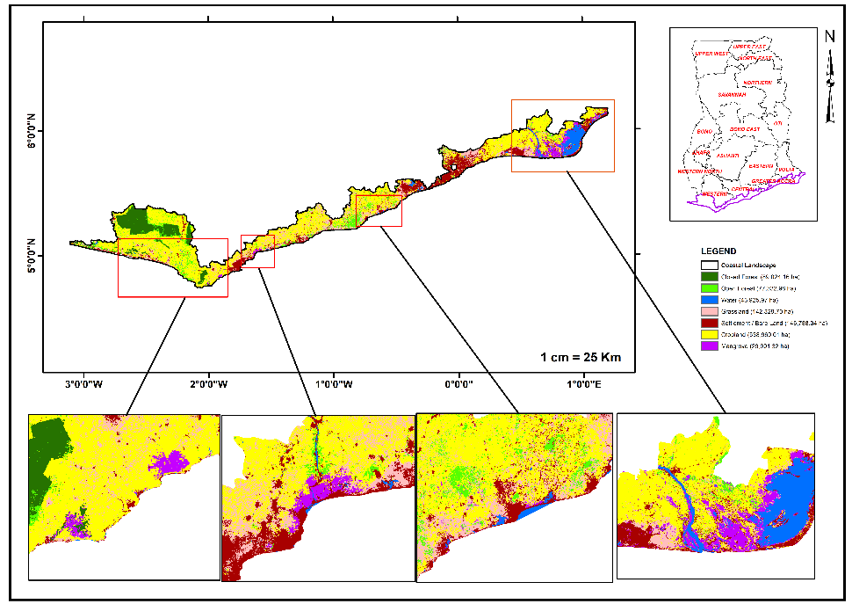

Figure 1: Landcover - Coastal Landscape
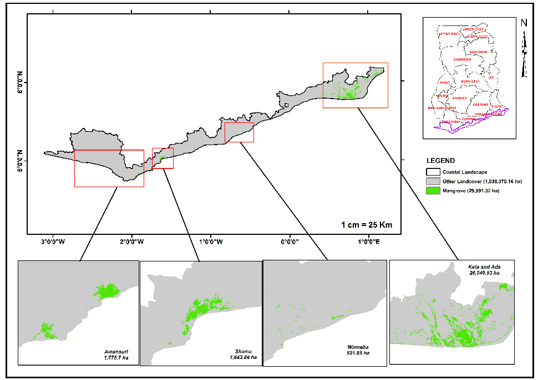
Figure 2: Mangrove Distribution Map – Coastal Landscape

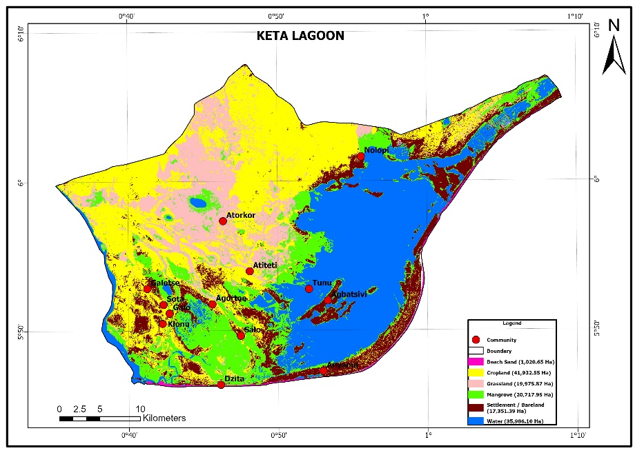
Figure 3: Landcover Map – Keta Lagoon
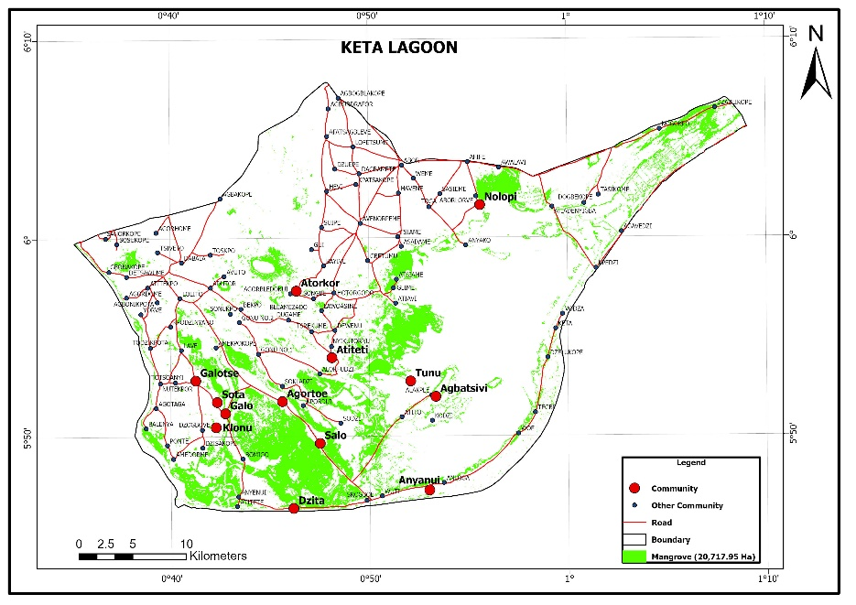
Figure 4: Mangrove Distribution Map – Keta Lagoon

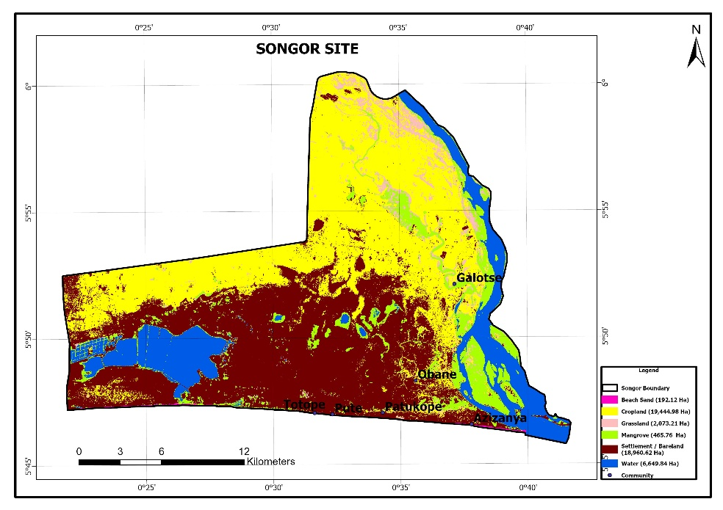
Figure 5: Landcover Map – Songor

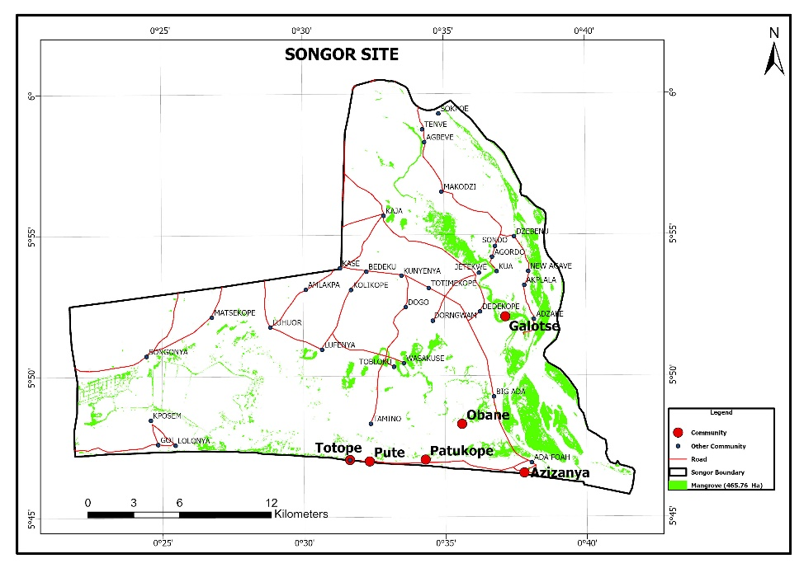
Figure 6: Mangrove Distribution Map – Songor

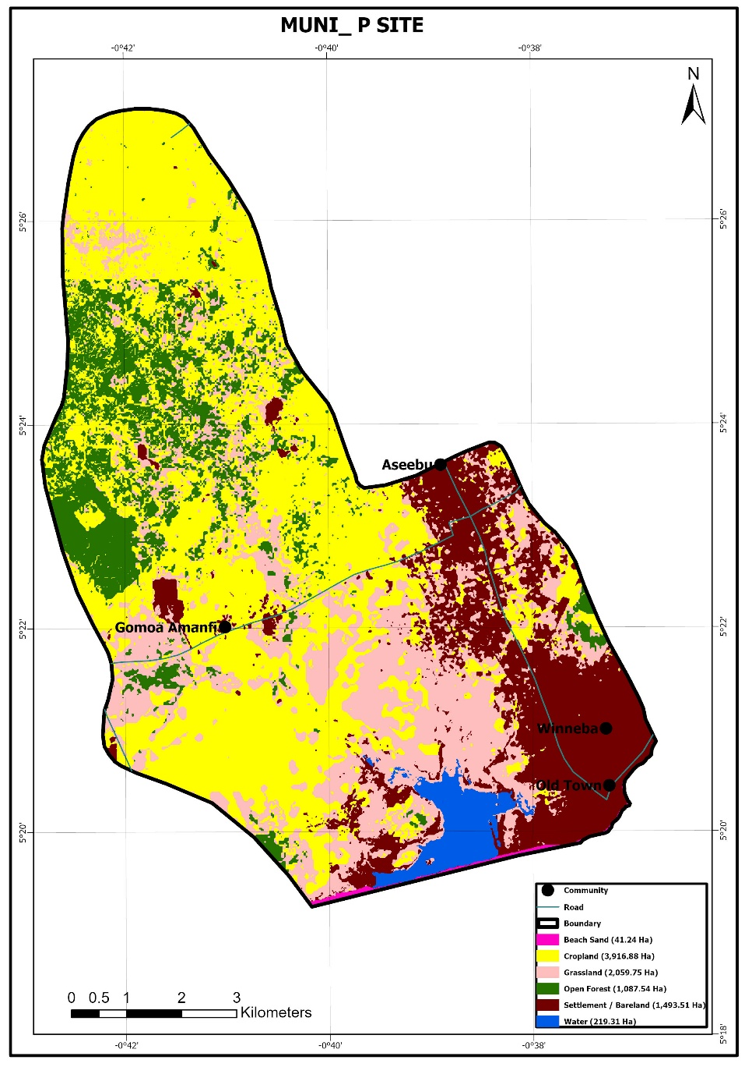
Figure 7: Landcover Map - Muni Pomadze

